**aws youtube notes handwritten by Akil**

IAM IDENTIY ACCESS MANAGEMENT

users :

Groups : multiple user here in group like admin, user etc

Roles: gave permission to service to access different services not for users

Policies: individual polices were assigned to user/roles

Practical use of IAM

1. Open aws management console 🡪 SELECT IAM in search then (IAM no need to select region specific)

add user



click on add user

I’m going to create group click no button , we need to give administrators policie and grou pname

Give tag to show identify amongst them

Finalluy review and create user

Then download the .csv file

After downloading that we get this 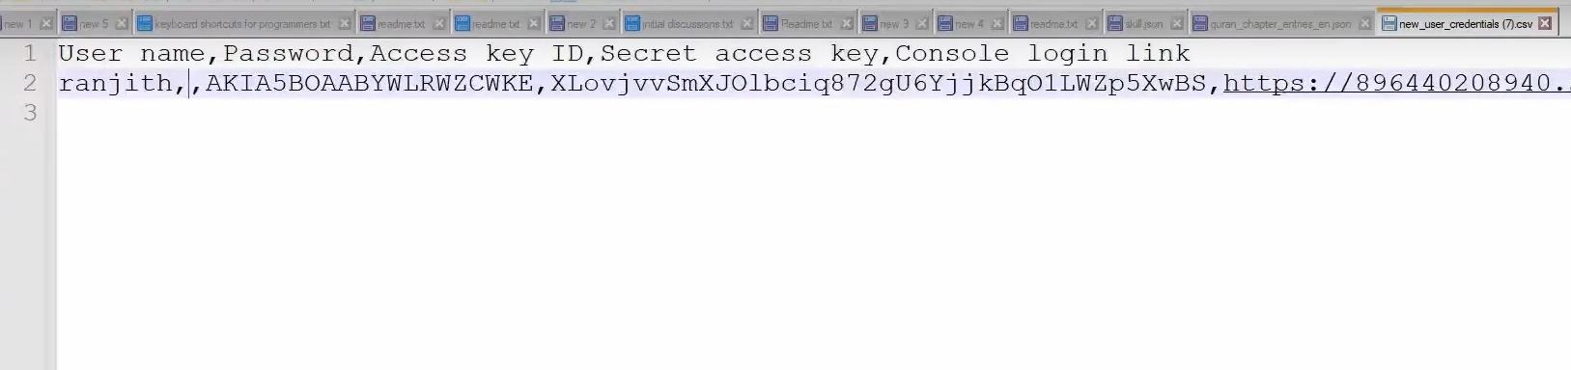

Best practices

Always give least privileges like for eg if you are going to create a new user try to give least minimal permission if you give unwanted **exrtra access** permission may be that use can do

1. How to login with programmatical and CLI?

Sdk means already an pacakage exist

Cli means using commandprompt

First cli

Step1:

install this setup

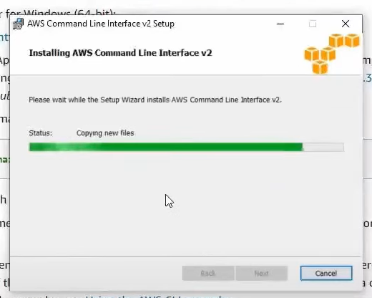 to check the installation successfully open cmd and type version – aws

then

Using sdk

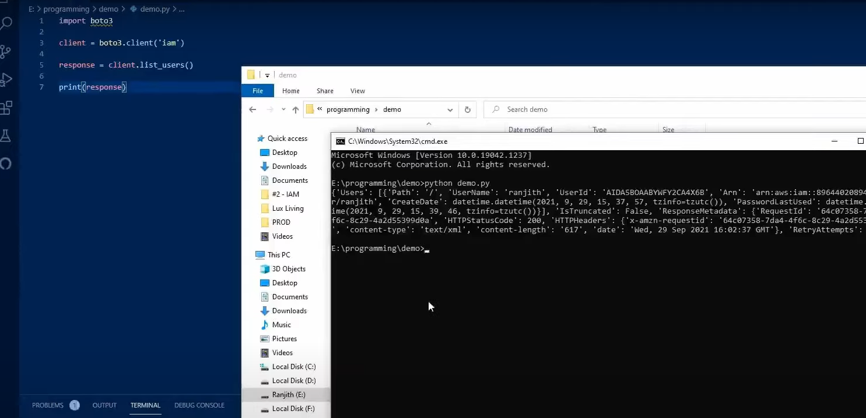

**AMAZON EC2**

This is used to run a virtual machine, an iaas , an fundamental to understanding how cloud works

To be continuer

**EBS**

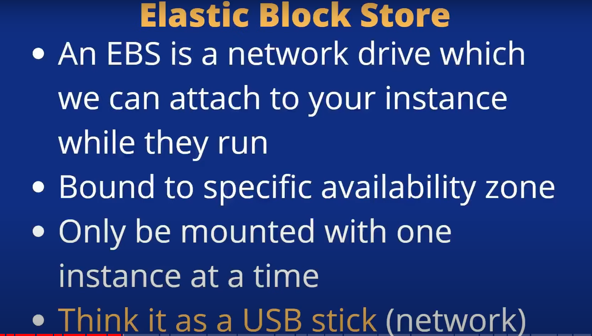

created ebs should be in same AZone even though it is in same region to attach

Here demo with already created instance

**Step 1**; you can see that by **default some ebs get attached** you can see that in storage tab of instance details

Here note that delete on termination is yes which indicate ? idk

Below image you can see the already creartefd instance and storage tab an default volume is already creaeted

**Step2:** To create a new EBS and going to attach it to this already created instance

**Step3**: create new volume ,Here give the details select the available zone the same as which is used for the created instance or else we are unable to attach it

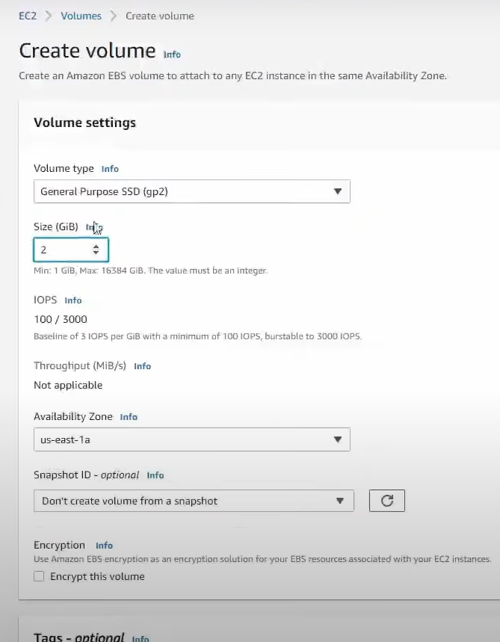

**Step4:**Once volume status Is available we need to attach it to our instance as shown in below image (click on **attach volume**)

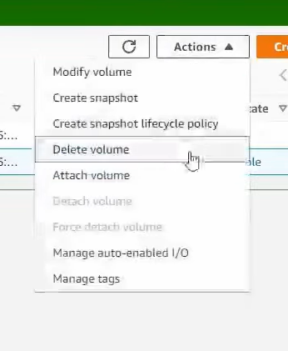\

Like this here select the appropriate instance and click on attach volume

**Elastic File System EFS** 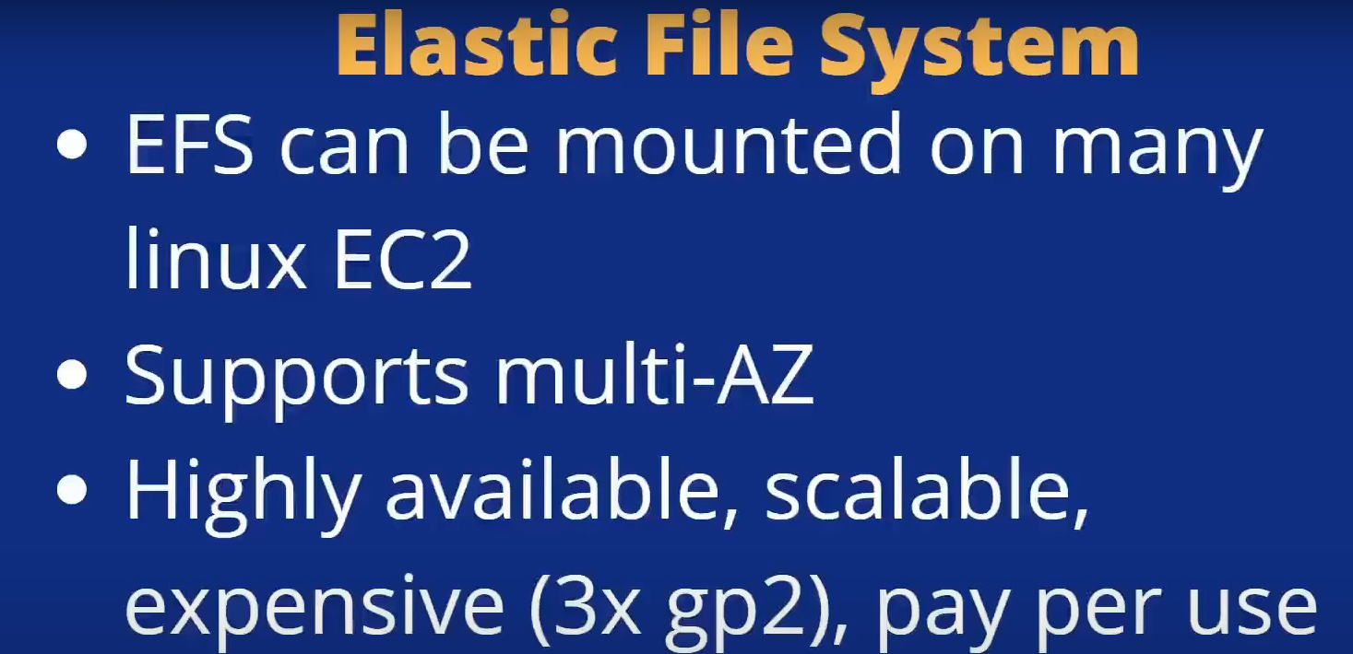

Difference btwn ebs and efs

In ebs we can connect only one instnace with it but in efs we can connect with many ec2

Efs support only with linux ony

In efs there is no restriction on attaching with ec2 instace like az zone

Steps for creating EC2 instances

While creating instance we have the optoin to select fils seyetem at the end

To selec the file system in storage volumn section we need to selec the subnet which Is in top network setting edit icon 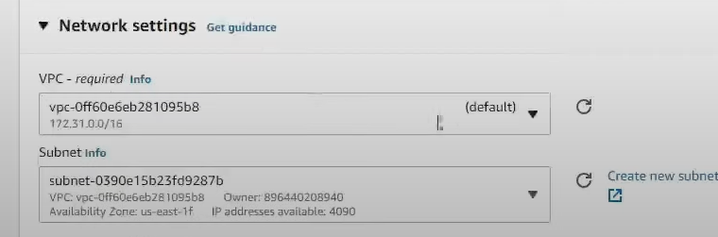

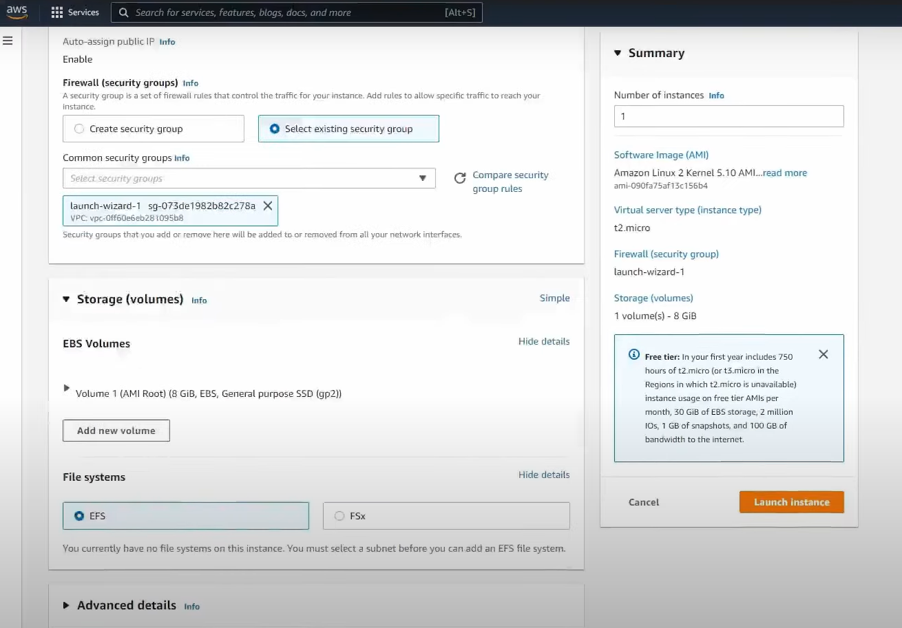

Copy the mount point info we need to paset it

finally launc the instance

For this demo we actually we need to create two instances 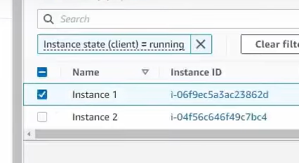then we need to conect

Like this connec two instances

we get like this in browse itself

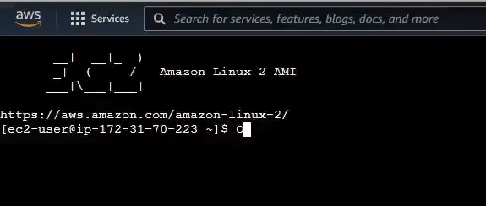

Actually this is the same as lke we did befor how we created instacn in local and login same like that

Ec1

Ec2

we can see the differen btwn instnave 1 and 2 on down side

Overall **EBS** bound to a specific availibilty zone and **EFS** are for multiple AZ but should be same region

EFS is automatically scale up but it cose is 3 time higher than ebs

**Scalability and High availability**

Scaling means system can handle higher load by adapting

2 types

**Vertical**

**Horizontal(eleasticitly**) increas number instances 

High availability means running you application in two data center goal is to survive data without data loss

**Load Balancer**

Server that forward traffic to multiple server

Single pont of access(DNS) to your application, do regular health check to you instances and

**Types**

Applicaton lb,

Network lb

Gateway lb

Demo of load balancer

First create an ec2 instance

Going to create application lb

Quiz set 13

878 amazon **sqs simple queue service** = to decouple the application

**Backup and restore**== is the least expensive disaster recovery

<https://docs.aws.amazon.com/images/whitepapers/latest/disaster-recovery-workloads-on-aws/images/disaster-recovery-strategies.png>

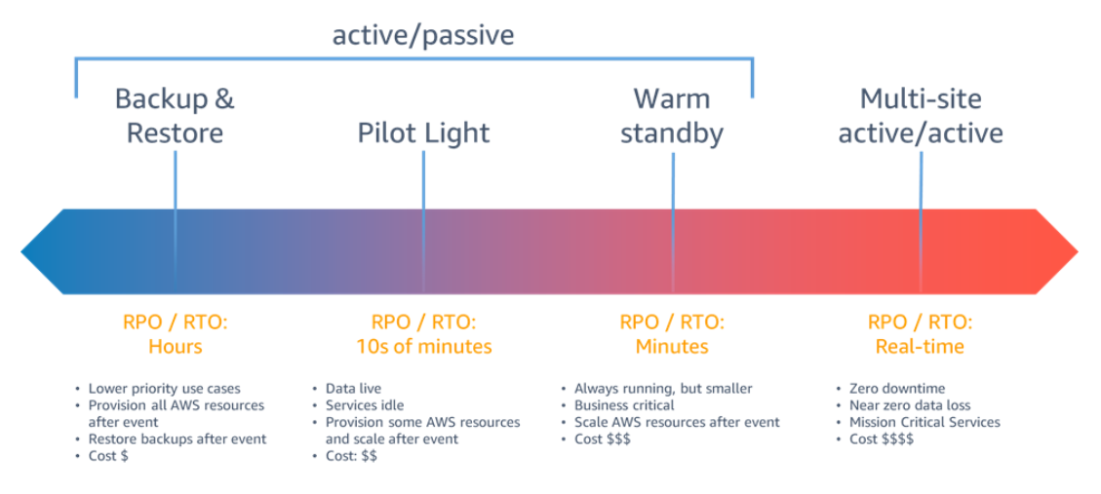

184. **all upfront reserved instance**= hint continuously running for 1 year and cannot tolerate service interruption & most cost effective

Waf= por css

**Aws pricing calculator**=a company want to forcast the cost of running a large application on aws

901. **AWS storage gateway** =if the tape library is out of space then company need to extend the Tape libr capacity to aws cloud

904 vpc flow log = it will cathc inbound and out bound of traffic in amazon vpc

906 if comp created an iam user instead of role?

when the copany want to create aws sccount for individual & when company need to add user to the iam groups

**aurora and dynamodb** = if comp want to **replicate** data across multiple available zone

**service control policies**= are type of organzation policies

enhanced security & compute capacity that adjusted on demand

**Amazon Elastic Transcoder** is media transcoding in [the cloud](https://aws.amazon.com/what-is-cloud-computing/). It is designed to be a highly scalable, easy to use and a cost effective way for developers and businesses to convert (or “transcode”) media files from their source format into versions that will playback on devices like **smartphones, tablets and PCs.**

Patch management & aws awareness training

**Amazon AppStream 2.0** is a fully managed application streaming service that provides users with instant access to **their desktop applications** from anywhere.

**IAM Access Analyzer** which check access policies and offer actionable recommendations

And also checked whether the iam role is shared with external entity

**AWS global accelerator**= to improve overall availability and performance of the application

**AWS infrastructure Event Management** = if the company has enterprise support plan. It provide guidance about how company should scale its architecture support during the event

Nalc which process rule in order, starting with lowest numbered rule, when decide whether to allow traffice and they are stateless\

RDS and Dynamodb are the fully managed db

**Aws service catalogue** = if a company want to limit it access to portfolio of predifned aws resources

Customer gateway and private gateway are the : aws site to site vpn connection components

Vpc peerinng is used to establish a connection between two vpc and also the two vpc is located in different locations

**Use cloud trails** to see whether the security group is modified last month

There is no upfront cost cmmittment bcz of this cloud pricing model differ from traditional onpremise storage pricing

For review also hit answer is cost explorer

**Aws consulting partner** = consider a company want to migrate to aws but it lack expectations in aws cloud computing

**Aws quota** = is used to centrally request and track service limit

**Changing the aws support plan** = aws root user characteristics

**Operation excellence and business agility**= benefits of migrating to aws cloud

One or more discrete data center **= availability zone**

**Quiz set 12**

**Aws cost anamoly detection** = use ml to continuously monitor cost and usage of cloud spending

The web application require credentials and authorization to use an aws serfvice = need iam role

**EC2 instance and RDS instances** = if a company is creating a document that defines the os patch routine for all the companys system

**AWS system manager parameter store**== a centralized storage system to manage the c**onfiguration data & password** for critical

**EC2 imagea builder** = assist with creation testing and management of custom amazon ec2 images

Capability gap hitn == align one of the cloud transformation jouenry

Amazon s3 file gateway= to migrate it nfs on prem workload to aws

Amazon fsx a fully managed file server for it’s window based application

**Iam roles** the user want to make call from one ec3 insta to other resoureces- grant access

Aws storage gateway = that provide virtually unlimited storge to onprem

**Aws personal health dashboard**= provided a customized view of health of specific aws serivces

Aws trust adviser = if a company wants to misconfigured security groups that allow acces to restrivted …

Cloud trail can identify if an ec3 is terminated

**Aws secutiry hub** that aggregate alleart for various aws service & it is a cloud security posture management

Lower variable cost over fixed cost = is the benefir of econmic of aws

**Aws security token service sts** -if the applica need to use temporary , limited priviledge credential FOR authentication for otheraws api’s

Cloud fluency belongs to people perspcetive

**Aws region**  hint geographical area

Access key-if a user need a programatic access to aws resources thorugh cli or api

Knowledge center = whchi gaves the most frequently asked security questeions

Aws pofession service = global team for suppot the migrariton faster and more reliable

**Aws resource exploree**- if a company wan to manage it service and govern it iac templates

K

**Aws cloud practitioner mcq hint based**

1. **Cloud trail** = ec3 preiously accessed now no longer accessible so to monitor this
2. **Cloud watch** = audit , log, trouble shoot, tracking of ec2 detailed information
3. **CLI** = if a develper need to quicklu provision and manage service by script
4. **Data sync** = infligh e=ncruption and end to end data validations , onprem to aws migraition
5. **Aws cloud formation** = infra as a code, in repetable manner
6. **Code star** – cici pipeline easy deployment
7. **Aws outpost** – low lateny, hybrid , service used in cloud but infrastructure is in on prem dc
8. **Workspace** - =desktop environment for serveral emplouee
9. **Aws organization** – consolidated billing
10. **Fargate**- serverless compute for container
11. **Waf** – web app firewall hint sql in=jecticion or cross site sceipting attack
12. **Vpc flow logs**- abitlity to capture n/w traffic in vpc
13. **Inspector** – security & complains of application deployed on aws
14. **Ebs and efs** – data were not deleted even if you reboot the ec2
15. **Ec2 instacnce store** – data is deleted if you reboot the ec2
16. **Amazon fsx file gateway** – windows file share form onprem to aws
17. **S3** – unlimited storage and low cost
18. **Cloud watch alarm**- acmp want to add/remove ec2 instance based on cpu utilization
19. **Sqs simple quere service**- decoupling
20. **Data migration service dms** – oprem db to cloud db service
21. **Fsx for windows file servier** – support smp protocol
22. **Fxs for lustre** – not designed for native winodws file system, compute intensive workloads